|  |
| --- |
|  |
| CSC124-N801 Project 3 |
| Market Basket Analysis |

|  |
| --- |
| Gregory Campbell  4-27-2022 |

What time do people often purchase online?

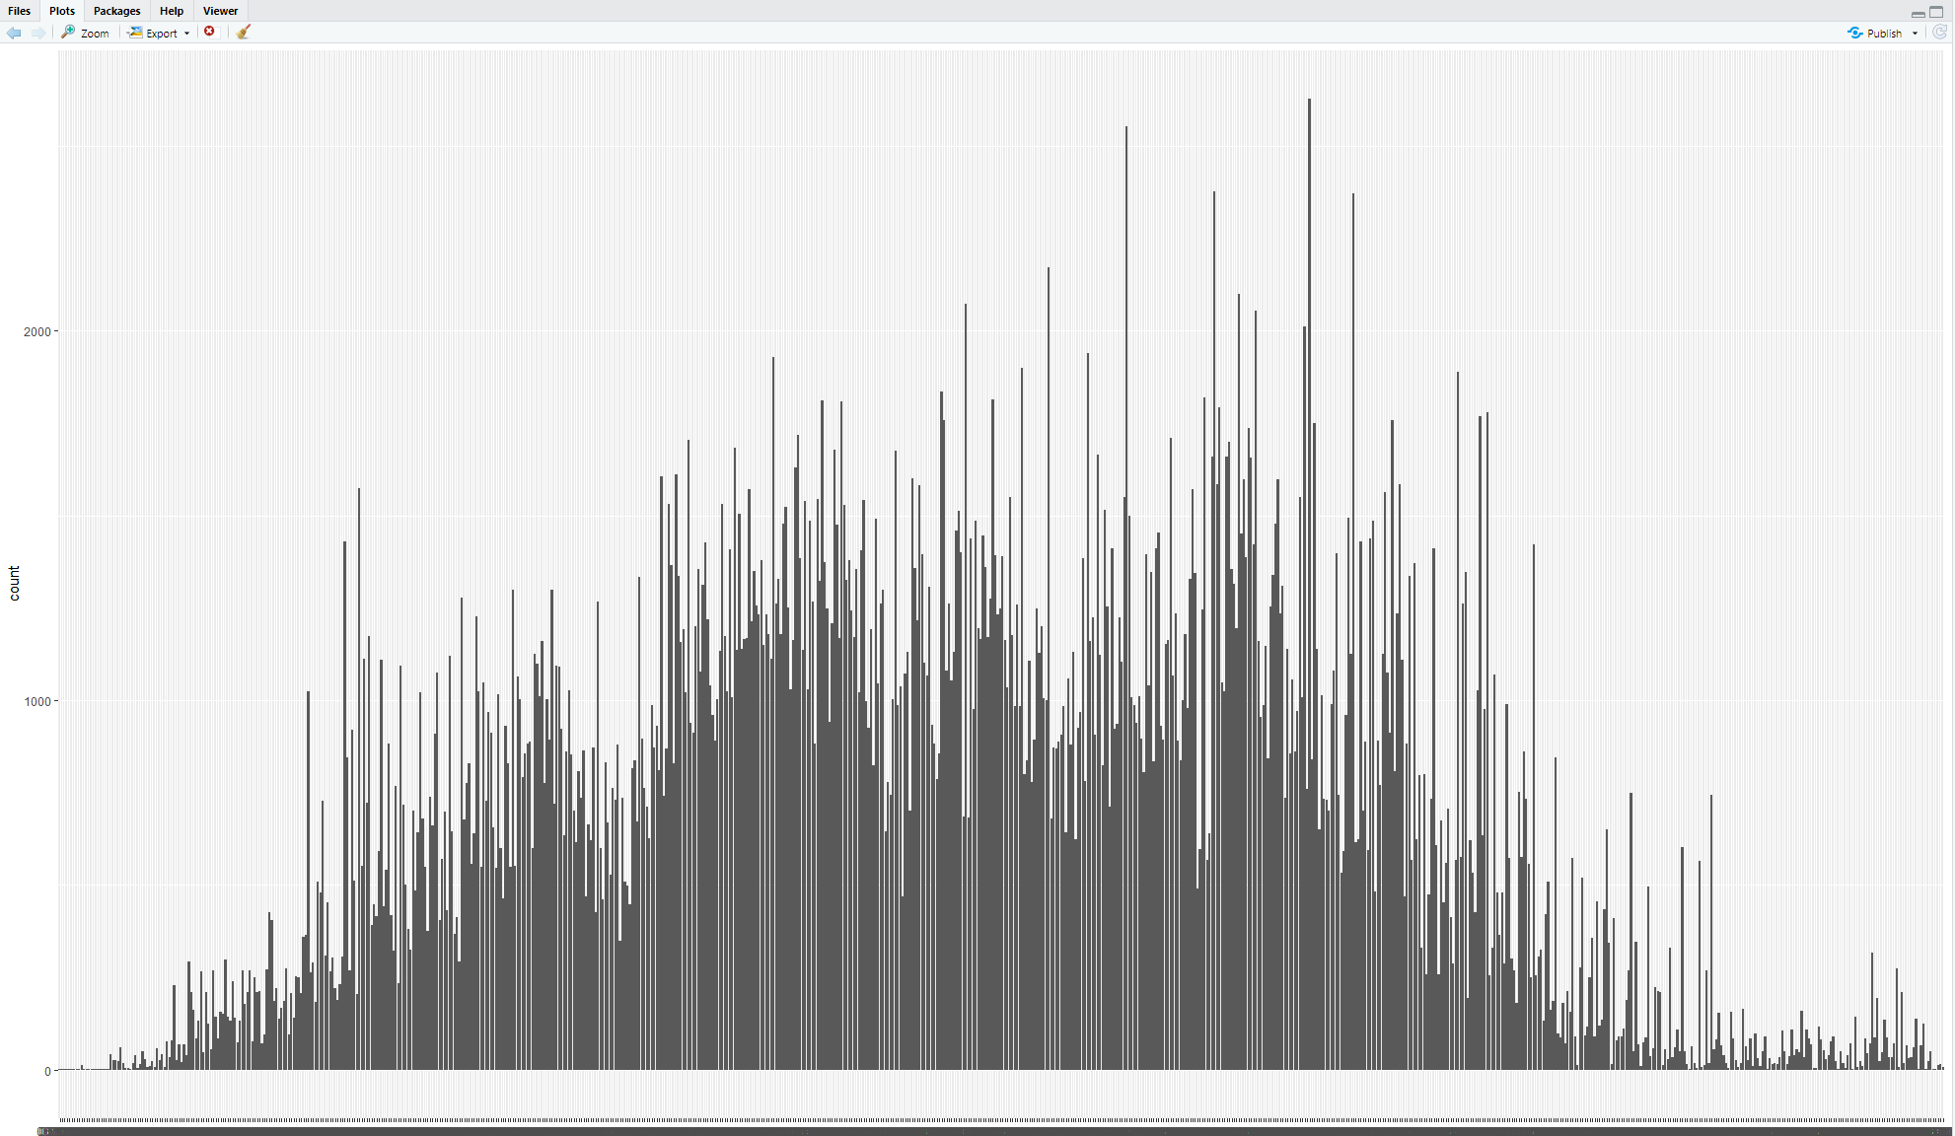

The first bin on the left side is 6:10am, the last bin on right is 20:38, so the biggest spike is around 4:30pm. Overall, late morning to early afternoon are the times of most purchases.

How many items did each customer buy?

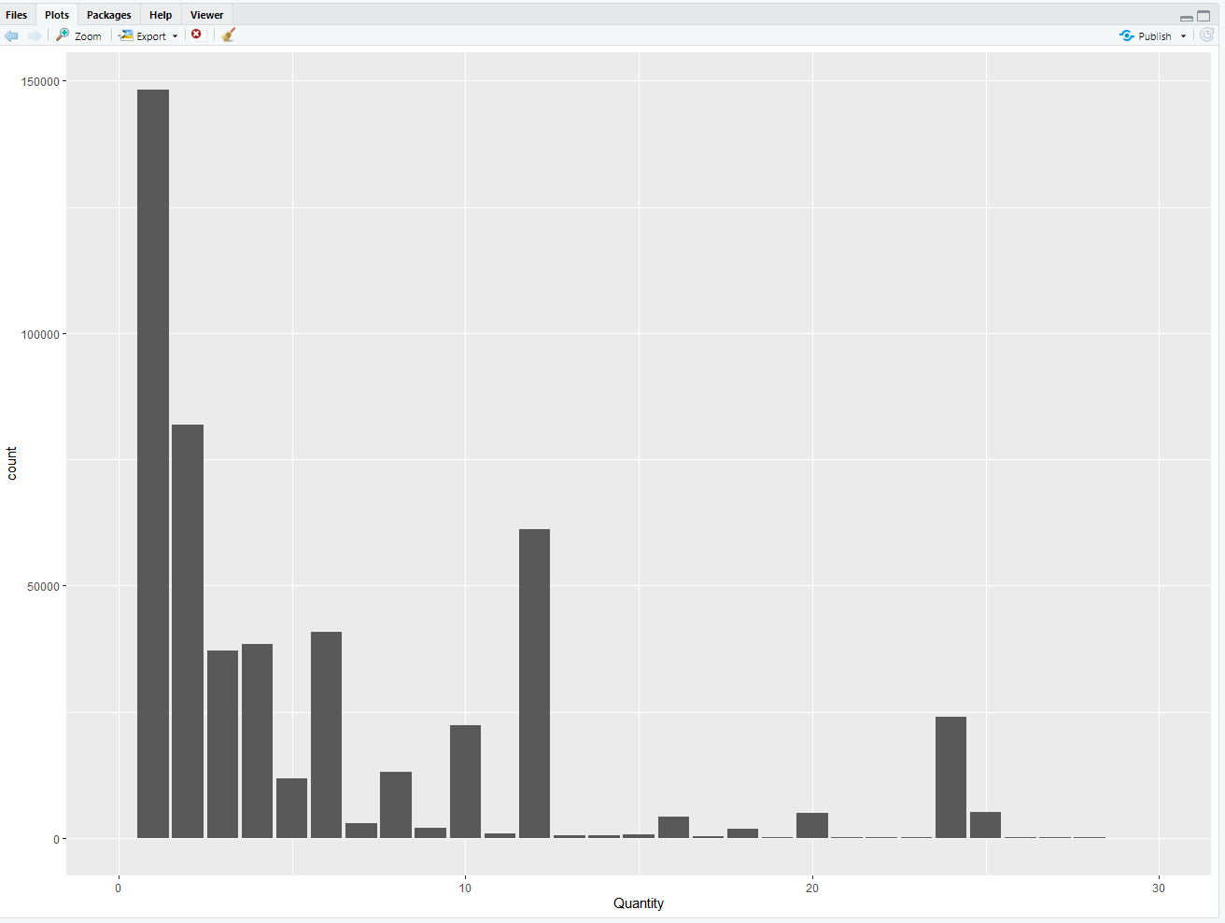

Most purchases consisted of 1 item.

What are the top 10 best sellers?

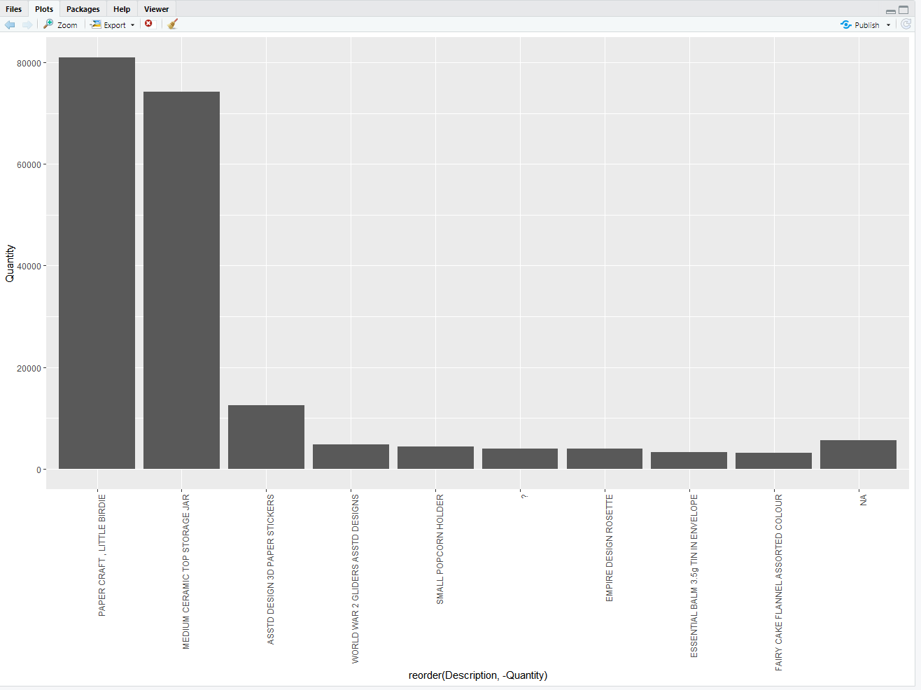

The top 10 are listed on the x-axis above.